Use Case Template
HiTech Personal Banking System
Project Id -1
Document Version / Details : Ver 3.0/01-Mar-05


Record of Release

Version No. | Modified By | Reviewed By | Authorized By | Release Date | Modifications Done
1.0 | Team | Vishal Dawane |  | 8/10/15

Table of Contents
1.0 Introduction 3
1.1 Overview of the Use Case Document 3
1.1.1 Purpose of the Document 3
1.1.2 Distribution List 3
1.2 Scope of the Project 3
2.0 Use Cases 3
2.1 Use Case Summary 3
2.2 Use Case Details 4
2.3 Use Case Diagram 7
3.0 Supplementary Specification 7
4.0 Document Reference 7
5.0 Glossary of Terms 7

Introduction

Overview of the Use Case Document
This document is used to capture Use cases, an alternative method to capture functional requirements defined in Requirement specification template.

Purpose of the Document
The purpose of this document is to collect and analyze all use case diagrams that have come up to define the system, its requirements with respect to customers. Also, we shall predict and sort out how we hope this product will be used in order to gain a better understanding of the project, outline concepts that may be developed later, and document ideas that are being considered, but may be discarded as the product develops.

Distribution List
This following list of people will receive a copy of this document every time a new version of this document becomes available:
Team Members: Bhavesh
Swati
Snehal
Akash
Yogalakshmi
Arpit
Guidance Team Members: Vishal Dawane
Customer: L&T Infotech

Scope of the Project
Project scope is defined in HiTech Personal Banking System Requirements Specification document.

Use Cases
Use cases are a mechanism to gather and document requirements to keep it simple and understandable for all stakeholders. Essentially they are stories of using a system to meet goals. Focus is on the question “How can using the system provide observable value to the user, or fulfill their goals?” We write Use cases in an essential style with focus on actor intent, but without user interface details.

Use Case Summary

Use Case Id | Name | Priority | Related Use Cases | Remarks
UC_01 | HiTech Banking System | High | None | Entire System
UC_02 | New User | Low | None | Extra Feature

Use Case Details

Use Case ID:  UC_01 | Use Case Name:  HiTech Banking System |  | Version No: 1  Date: 6/10/2015
Primary Actor: User |  | Client Ref: Admin
Brief Description: The HiTech Banking System use case consists of all the entities and the flow of the entire banking system. The User is the primary actor in this use case, the admin and the beneficiary are the secondary actors. The Login module is the primary module and extends all the other modules.

Stakeholders and Interests:
Stakeholder1 (Primary Actor): User
Stakeholder2: Admin
Stakeholder3: Beneficiary

Preconditions:
No pre-conditions

Success Guarantee (Post conditions):
No post-conditions

Main Success Scenario (Basic Flow):
The User is able to login into the website and able to transfer funds and generate report and account summary.

Extensions (Alternative Flows):
The User can visit the Loan and Insurance subsidiaries through the bank’s website

Relationship with Other Use Cases:
“include”:
None
“extend”:
Personal Details, Account Summary, Fund Transfer and Report
“generalization”:
None
Special Requirements:
The User is already a customer of the HiTech Bank and has the login credentials

Technology and Data Variations List:
The User can visit the Loan and Insurance subsidiaries through the bank’s website and come bank to perform independent fund transfer.

Frequency of Occurrence:
Negligible, since the User is visiting a bank’s website and shouldn’t be much interested in the loan and insurance activities.

Performance Goals:
The User should be able to use all the basic functionalities of the web application

Open Issues:
New User Login is not supported at this moment

Use Case ID:  UC_02 | Use Case Name:  New User |  | Version No: 1  Date: 6/10/2015
Primary Actor: User |  | Client Ref: Admin
Brief Description: The New User use case consists of the flow of apply online feature. The User and the admin are the primary actors in this use case. There are no secondary actors.

Stakeholders and Interests:
Stakeholder1 (Primary Actor): User
Stakeholder2 (Primary Actor): Admin

Preconditions:
No pre-conditions

Success Guarantee (Post conditions):
No post-conditions

Main Success Scenario (Basic Flow):
A New User (Customer) is able to apply online for opening a bank account and this request is sent to the admin (bank employee) for further processing and decision.

Extensions (Alternative Flows):
None
Relationship with Other Use Cases:
None
Special Requirements:
None
Technology and Data Variations List:
None
Frequency of Occurrence:
None
Performance Goals:
The New User (Customer) should be able to apply online for opening a bank account by filling in his\her details in the apply online form

Open Issues:
None

Use Case Diagram
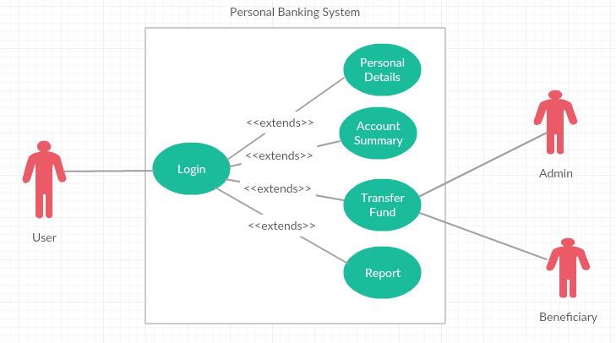

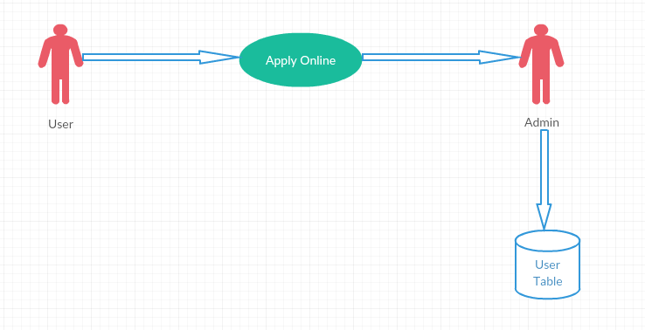

Supplementary Specification
Same has been addressed in the Requirement Specification Document.

Document Reference
The document titled ‘Project Gladiator Case Study Banking’ provided by the customer has been referred for gathering requirements.

Glossary of Terms

Sl. No. | Business Term | Description
 | SRS | Software Requirement Specification
 | SDLC | Software Development Lifecycle
 | NEFT | National Electronic Fund Transfer
 | RTGS | Real Time Gross Settlement
 | GUI | Graphical User Interface
 | DBMS | Database Management System
 | JVM | Java Virtual Machine
 | JSP | Java Server Pages
 | HTML | Hyper Text Markup Language

